JOB SATISFACTION AMONG HIGHER EDUCATION LIBRARY
Vineet Kumar
M. Phil, Roll No. 141203; Session-2014-15
University Department of library science, B.R.A. Bihar University, Muzaffarpur, India
E-mail: jhavineet.jha@gmail.com
ABSTRACT
The concept of Human Resource Management and the level of job satisfaction among the employees of an organization or an institution is a topic of public interest and is widely studied in the contemporary times, particularly in the corporate sector where the emphasis is always laid on the level of job satisfaction of its human resources, which they rate as the company's ultimate asset. This topic is of public interest and is widely studied because it is a subject of public interest and because it is a subject that is widely studied. The phrase "work satisfaction" may mean very different things to very different people, and each person has their own unique understanding of what it means to be satisfied in their employment depending on the logic that they employ. In addition, there are certain overarching definitions that might assist in the process of comprehending the concept of job satisfaction. According to Schneider and Snyder (1975), job satisfaction may be defined as an effective reaction that workers have towards their work and organization.
Keywords: Satisfaction, Job, Higher, Education

INTRODUCTION
The concept of Human Resource Management and the level of job satisfaction among the employees of an organisation or an institution is a topic of public interest and is widely studied in the contemporary times, particularly in the corporate sector where the emphasis is always laid on the level of job satisfaction of its human resources, which they rate as the company's ultimate asset. This topic is of public interest and is widely studied because it is a subject of public interest and because it is a subject that is widely studied. These days, we can observe that the level of work happiness is being analysed among employees in every kind of institution or organisation, which indicates that the trend of measuring the level of job satisfaction among human resource personnel has spread beyond the realm of the business sector. In light of this reality, the purpose of the current study is to explore the degree of job satisfaction among working professionals in the fields of library science and information science in India.
The phrase "work satisfaction" may mean very different things to very different people, and each person has their own unique understanding of what it means to be satisfied in their employment depending on the logic that they employ. In addition, there are certain overarching definitions that might assist in the process of comprehending the concept of job satisfaction. According to Schneider and Snyder (1975), job satisfaction may be defined as an effective reaction that workers have towards their work and organisation. According to Ejiogu (1980), job satisfaction refers to an individual's overall social and psychological well-being. This definition assumes that factors such as interpersonal relations, pay, fringe benefits, promotions, involvement in the decision making process, and proper communication all contribute to an individual's sense of fulfilment in their work. According to Middlemist and Hilt's (1981) research, having a positive or negative emotion about one's job and the work environment in which one works is the most important factor in determining job satisfaction. According to Arnold and Feldman (1986), having a beneficial influence on others as a result of one's work, enjoying the atmosphere in which one works, and feeling an emotional connection to one's work all contribute to one's level of job satisfaction. According to Hoy and Miskel's (1987) definition of job satisfaction, it is the combination of a person's psychological, physiological, and environmental conditions that leads them to say, "I am content with my job." Hoy and Miskel argue further that job happiness is more about delivering overall contentment, job stability, remuneration, progress, and promotion with cordial interpersonal interactions, both at the subordinate and the super-ordinate levels of the organisation.
Even though the field of library and information science has been around for more than 130 years, it still has not achieved the level of importance that it otherwise ought to have. Even though they are considerably newer than Library and Information Science, a considerable number of topic disciplines have sprung to prominence within the shortest amount of time since coming into being. One of these fields is library science. It has also been noticed that professionals working in LIS domains throughout the world, in general, and in India, in particular, do not have the same high professional standing as their peers working in other scientific subjects or in a variety of other academic and professional sectors. In light of this reality, it is of the utmost importance to investigate the factors that, on the whole, contribute to feelings of discontentment at work among library professionals all over the world, and in India in particular.

IMPORTANCE OF JOB SATISFACTION AMONG AGRICULTURAL FACULTY MEMBERS
It is imperative that faculty members at agricultural colleges feel fulfilled in their work in order to propel the educational systems of these institutions forward in the direction of obtaining greater levels of efficiency and effectiveness in the learning and education processes. In addition to this, it helps faculty members maintain a healthy mental state, which, in turn, has a positive impact on their ability to complete their work quickly and effectively, as well as on their ability to maintain their psychological, social, and professional composure in their roles as researchers and extension specialists in universities. Because they are the most important pillars of these educational institutions, the faculty members at universities should feel a high level of job satisfaction. This is because they are responsible for providing students with theoretical and practical experience in a variety of fields of knowledge in an efficient and effective manner. A number of studies have shown that job satisfaction positively affects the achievement of psychological adjustment, reduces the psychological distress, and also fully increases both practical and professional outcomes among faculty members. A lack of job satisfaction is the cause of professional backwards for agricultural universities and their faculty members.
society as a result of their efforts to enhance the quality of education and establish agricultural systems that are in conformity with the most recent academic advancements, extension services, and the requirements of society. It is also significant since they regarded the core of academic and scientific work at the university, and they successfully contribute to the intellectual and ethical development of the individual. Because they are the ones who teach students and provide direction, faculty members are regarded as the most important factor in determining whether or not the institution will be successful in accomplishing its mission. They are the ones who evaluate their own learning activities, as well as the ones who assert, develop, and share their knowledge. In addition to this, they are responsible for the implementation of programmes that involve community service, as well as the process of development and building within the institution and the society.

OBJECTIVES
- to determine the amount of job satisfaction experienced by library professionals who differ in terms of their educational background, gender, and marital status;
- to determine the levels of work satisfaction accorded to each group;

RESEARCH METHODOLOGY
The processes that a researcher adheres to in the course of carrying out his or her research activities are what are referred to collectively under the phrase "research methods or techniques." The methodology is a technique that researchers follow, and the research endeavours to address a study issue by using this methodology, which is a method. When it comes to analysing and investigating a research problem, a researcher may use a variety of strategies and approaches, all of which are determined by the particulars of the problem itself. The specifics of the problem itself can be determined by visiting the website of the National Center for Biotechnology Information. The following section offers a clear and simple explanation of the research design, the size of the study's sample population, the survey instrument, and the procedures that were utilised in order to analyse the collected data. The descriptive research technique has been picked as the right way for this particular study endeavour. This was done in order to generate genuine situations, acquire precise and sufficient information, and arrive at a definitive evaluation.

Research Design
The collecting of data is of the biggest importance in this research design as it makes it possible to acquire qualitative and quantitative information about a study subject. The current study made use of a number of different research approaches, such as an examination of historical records, a review of the pertinent literature, and a questionnaire survey. These surveys proved to be useful in the process of acquiring textual data from a wide variety of published and unpublished sources. The utilisation of the questionnaire approach, which is an extremely helpful tool, may be utilised in order to elicit the feedback of LIS professionals. Figure 1, which can be seen below, depicts the progression of the research work that was carried out for the current study.
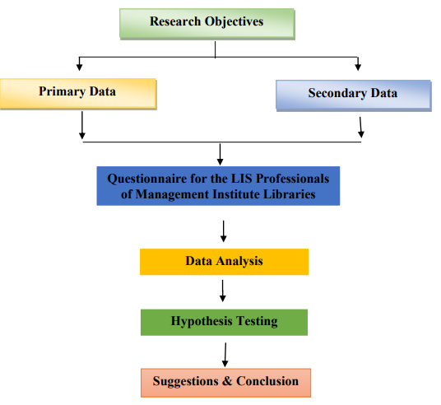
Figure 1: Flow of the Research Work
ANALYSIS AND INTERPRETATION OF DATA
This project's goals are to (1) identify and investigate the association variables that have a significant impact on the level of job satisfaction in both the state of Bihar and the state of Jharkhand; (2) determine the various levels of job satisfaction that exist among the selected information science professionals working in management institutes in both of these states; and (3) determine the various levels of job satisfaction that exist among the information science professionals working in management institutes in both of these states. In this chapter, I will study and contrast a number of various features that contribute to an individual's degree of happiness in their line of work. Specifically, I will focus on the factors that lead to an individual's level of job satisfaction. The majority of those who worked in libraries and took part in the research were trained professionals in the LIS field. LIS professionals are those who have earned a master's degree in Library and Information Science and are currently working in management positions in different types of institution libraries.
The primary data came from a survey that had been meticulously designed and then distributed to a group of LIS professionals with the purpose of collecting their feedback. The questions that were asked about the services, the collection, the working environment, job happiness, motivational factors, social recognition, and remuneration, in addition to the questions addressing the effect of ICT on job satisfaction. The questionnaire has been designed to be straightforward and easy to understand so that the respondents will be able to articulate their points of view in a fashion that is commensurate with the expectations of the project. In an effort to improve accessibility and communication, this has been done. We provided LIS professionals the ability to self-administer the questionnaire because we wanted to make things as simple and straightforward for them as we could possibly make them. On a scale known as the "Likert," responses were given a score between one and five points, and response anchors also received a score between one and five (1.Very Dissatisfied to 5.Extremely Satisfied). 2. Dissatisfied 3. I'm Not Really Certain About That 4. I Have No Complaints 5. Extremely Satisfied) with a check mark next to the one that matches to the perspective of the respondents the most closely (s). In order to guarantee that the questionnaires were delivered to the specialists, they were sent to them by certified mail. It is possible that the high rate of response to the current study is attributable to the fact that the researchers followed up with the specialists in both states via email, the telephone, and in-person visits to each of their respective institutes. This was done in order to ensure that they had the most up-to-date information possible. The next portion of the report contains a presentation of the key data that was obtained from the respondents. This information may be found in Section 2. Both Microsoft Excel and SPSS version 23, respectively, are utilised throughout the process of carrying out the data analysis.

BACKGROUND INFORMATION ABOUT THE RESPONDENTS

Distribution of Questionnaire in Both the States
A breakdown of the total number of questionnaires distributed to workers in the field of library and information science affiliated with management institutes in the states of Bihar and Jharkhand can be found in Table 1 This table displays the breakdown of the total number of questionnaires sent out. In the state of Jharkhand, there are 198 management institute libraries that are functioning, compared to the 382 management institute libraries that are active in the state of Bihar. A mix of basic random sampling and proportional random sampling was utilised in order to choose fifty percent of the total number of institutes to participate in the study. In the end, 191 colleges from the state of Bihar and 99 institutes from the state of Jharkhand were chosen for the study and taken into consideration since they have been granted recognition by the All India Council for Technical Education in New Delhi.
LIS professionals who are employed at management institutes in the states of Bihar and Jharkhand were each given one of a total of 617 questionnaires to fill out. We received a total of those questionnaires, and 541 of them were counted as answers since they were correctly filled out and returned. This gave us a response rate of 87.68%.
Table 1: Designation wise Distribution of Questionnaires in Bihar and Jharkhand States of Management Institute Libraries
Designation | Bihar |  | Jharkhand |  | Total
 | Questionnaire distributed | Questionnaire received | Questionnaire Distributed | Questionnaire received | Questionnaire distributed | Questionnaire received
Librarian | 191 | 177 (92.67) | 099 | 085 (85.86) | 290 | 262 (90.34)
Assistant Librarian | 215 | 182 (84.65) | 112 | 097 (86.61) | 327 | 279 (85.32)
 | 406 | 359 (88.42) | 211 | 182 (86.26) | 617 | 541 (87.68)

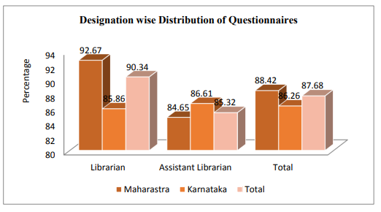
Figure 1: Designation wise Distribution of Questionnaires in Bihar and Jharkhand States of Management Institute Libraries
The distribution of questionnaires in terms of designation may be seen in Table 4.1 for the states of Bihar and Jharkhand. The response rate among librarians in the state of Bihar was the highest at 92.67%, followed by the response rate among assistant librarians at 84.65%. In comparison, the bulk of responses in the state of Jharkhand came from Assistant Librarians, who made up 86.61% of the total, followed by Librarians, who made up 85.86% of the total (Figure 1).

Qualification wise Distribution of Respondetns
The bulk of the respondents in the state of Bihar, 191 (53.20%), held a Bachelor of Commerce degree, while another 79 (22.01%) respondents held a Bachelor of Arts degree, and 89 (24.79%) respondents held a Bachelor of Science degree. Respondents typically hold advanced degrees in Library and Information Science, such a Master of Library and Information Science (MLIS), a Master of Philosophy (MPhil), or a Doctor of Philosophy (PhD). In comparison, the majority of respondents in the state of Jharkhand held a Bachelor of Commerce degree, which was 93 (51.10%), followed by a Bachelor of Arts degree, which was 52 (28.57%), and a Bachelor of Science degree, which was 37 (20.33%). Respondents typically hold advanced degrees in Library and Information Science, such a Master of Library and Information Science (MLIS), a Master of Philosophy (MPhil), or a Doctor of Philosophy (PhD). It has come to our attention that respondents in both of these states are actively working to advance their professional credentials by earning research degrees such as M.Phil. and Ph.D.

Gender-wise Distribution of Respondents
The responses of professionals working in libraries and information centres are broken down by gender in table 2. It has been found that the majority of respondents in the state of Bihar are males, with 194 males accounting for 54.04 percent of the total, followed by 165 females accounting for 45.96 percent. Comparatively, the bulk of the respondents in the state of Jharkhand are male 110 (60.44%), while the number of female respondents is 72 (39.56%).
Table 2: Gender wise Distribution of the Respondents
Gender | Bihar | Jharkhand | Total
 | No. of respondents | No. of respondents | No. of respondents
Male | 194 (54.04) | 110 (60.44) | 304 (56.19)
Female | 165 (45.96) | 072 (39.56) | 237 (43.81)
Total | 359 (100.00) | 182 (100.00) | 541 (100.00)
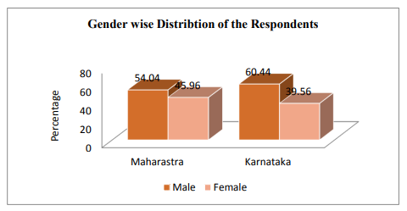
Figure 2: Gender wise Distribution of the Repondents
Age-wise Distribution of Respondents
Young professionals with less experience are just as necessary as those with more seniority in order to fulfil the requirements of management hopefuls and staff. It is of the utmost importance to have an understanding of the age range of LIS experts. The age groups of LIS professionals who are now employed in management institutes in the states of Bihar and Jharkhand are broken down in table 3.
Table 3: Age wise Distribution of the Respondents
Age group | Bihar | Jharkhand | Total
 | No. of respondents | No. of respondents | No. of respondents
25 to 35 | 111 (30.92) | 075 (41.21) | 186 (34.38)
36 to 45 | 135 (37.60) | 052 (28.57) | 187 (34.57)
46 to 55 | 079 (22.01) | 034 (18.68) | 113 (20.89)
56 and above | 034 (09.47) | 021 (11.54) | 055 (10.16)
Total | 359 (100.00) | 182 (100.00) | 541 (100.00)
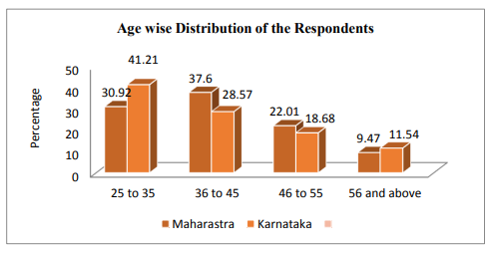
Figure 3: Age wise Distribution of the Respondents
According to Table 3, the majority of respondents in the state of Bihar, 135 (37.50%), fall within the age bracket of 36 to 45 years old. Approximately 111 (30.92%) of the respondents fell into the age category of 25 to 35, followed by 79 (22.01%) respondents who belong to the age group of 46 to 55, and then 34 (9.47%) respondents who fall into the age group of 56 and above. On the other hand, the age group of 25 to 35 years old comprises the largest proportion of respondents in the state of Jharkhand, 75 in total (41.21%). This is followed by 52 respondents (28.57%) who belong to the age category of 36 to 45, 34 respondents (18.68%) who belong to the age group of 46 to 55, and 21 respondents (11.54%) who belong to the age group of 56 and above. It is quite obvious that the bulk of respondents are young professionals working in the LIS field.

CONCLUSION
The option of obtaining a management degree at a higher education institution is now the one that is the most sought after by ambitious and talented graduates who are competing for a job in the corporate echelons. It is something that trains and develops an incumbent so that they can considerably nurture their emerging competencies. As a result of an increase in demand for trained management professionals that is outpacing the supply and a shortage of seats at the leading management institutes, there has been a substantial increase in the number of private management institutes that are being established in India under the auspices of the Association of Indian Councils for Technical Education (AICTE), which is located in New Delhi. The necessity of the hour is for Indian management education to become more globally focused so that the country can remain competitive. The calibre of an institute's faculty, as well as its fantastic infrastructure, teaching approaches, worldwide relations, and cutting-edge library sources and services, are all indicators of the institute's success and renown.
REFERENCES
- Adams, C. (2009). Library staff development at the University of Auckland Library – Te Tumu Herenga Endeavouring to "get what it takes" in an academic library. Library Management, 30(8/9), 593-607.
- Attafar, A., Simar, N. & Shahin, A. (2011). Effects of Demographic and Personal Factors on Job Burnout: An Empirical Study in Iran. International journal of Management, 28(4, Part - 2), .
- Aycan, Z., Kanungo, R. N., & Mendonca, M (2014). Organisations and management in cross-cultural context. London: Sage publication.
- Badu, E. E. (2005). Employee motivation in university libraries in Ghana: A comparative analysis. Information development. 21(1),
- Bellary, R. N. & Naik, R. R. (2016). Motivational Factors that Contribute to the Job Satisfaction of Library and Information Science Professionals. International Journal of Information Resources and Knowledge Management, 3(1),
- Bellary, R. N. & Naik R. R. (2014). I Love my job: Study of job satisfaction among library professionals working in B-schools in Patna City. Indian Journal of Library and Information Science. 8(3), 299 -305.
- Bellary, R. N. (2014). Factors influencing on job satisfaction of LIS professionals. Conference Proceedings of Digital Shift: Making Libraries relevant for education and research. 309-314.
- Bellary, R. N. (2014). Factors influencing on job satisfaction of LIS professionals. Conference proceedings of Digital Shift: Making Libraries relevant for education and research. 309-314.
- Bellary, R. N., Sadlapur, S. & Naik, R. R. (2015). The impact of ICT on Job satisfaction among library professionals working in NMIMS Deemed University, Patna. Library philosophy and practices. 1-14.
- Cassner, M., & Adams, K. E. (2006). Assessing the Professional Development Needs of Distance Librarians in Academic Libraries. Journal of Library Administration, 45(1/2), 81-99.
- Cuddy, C., & Medeiros, T. S. (2002). Designing a Library Staff Computer Training Program: Implementation of Core Competencies. Information Technology & Libraries, 21(2), 87.
- Da Silveira, J. G. (2009). Human resource management in university libraries: reflections. Information Science, 38 (2), 126-141.
- Dutt, R. (2006).Organisational structure and personnel management. Meerut: Krishna prakashan media (p) Ltd. p. 155-156.

